Student Name:  Name of Dance: | 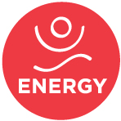

Mark how you think each kind of energy mostly happens in this dance.

EXAMPLE: Sharp ✖ Smooth

Attack
How does the dancer begin a movement?

Sharp Smooth

Sudden Sustained

Tension
What’s the muscle tone like?
How much are the muscles engaged and working?

Tight Loose

Force
How much effort is used?

Strong Gentlex

Weight
How does the dancer work with gravity?
Is the dancer grounded and connected to the earth – or floating and lifting away?

Heavyxxxxxxx Lightxx

Flow
How does the dancer connect the movements?
Is it tight & contained—or freely moving?

Bound Freexcc
(Constrained)

What are some other words that describe the energy in this dance? Write them here:

